Macromolecules Lab

What you need to know: a general understanding of the basic structure of each macromolecule that detect the presence or absence of key functional groups or overall characteristics in various substances. For example, what is it about the structure of lipids that cause them to show up when tested with Sudan IV?

Objective: Identify the presence of major nutrients such as simple carbohydrates (glucose), complex carbohydrates (starch), proteins and fats in common foods.

Problem:

Hypothesis:

Notes:

You will be using a number of different solutions to test for macromolecules.

Carbohydrates contain monosaccharides or disaccharides. Proteins contain peptide bonds. Lipids contain water-insoluble substances (recall that they are fats and are nonpolar). The only macromolecule you won’t test is nucleic acids.

Types of solutions/reagents that may be used:
Benedict’s solution tests for simple sugars. (Must be used with a water bath)
Iodine solution tests for starch (complex carbohydrates).
Biuret’s solution tests for proteins (amino acids).
Sudan IV tests for fats.

List your materials. What do you see?

Procedure:

You need ____ test tubes for each food. Put a small amount of food into each test tube. Number the test tubes and make a note of what each test tube contains and what reagent you will use for each test tube.

Document all of the steps that you take to test each food. Here is a YouTube video for reference. https://youtu.be/Jm5g5z2xndc

The chart below tells you what color indicates a positive test and a negative test.
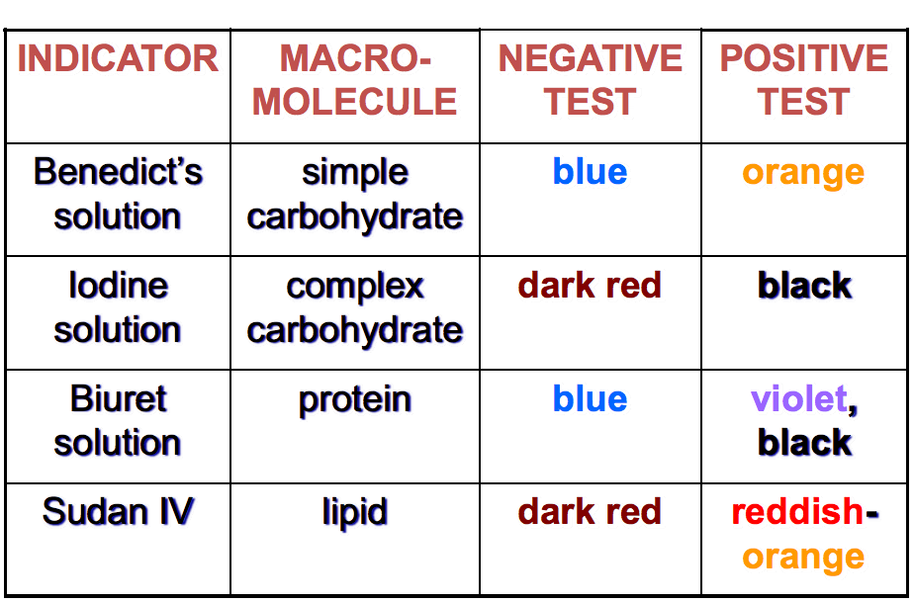

Your data needs to be collected in a table like below. Bear in mind that there may need to be adjustments based on what we are able to complete during lab. We may not have access to all of the solutions, so be careful to note what you are using.

Table 1: Tested Foods

Food | Tested For | Solution Used | Positive | Negative

What patterns do you notice?

